
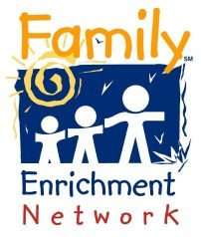
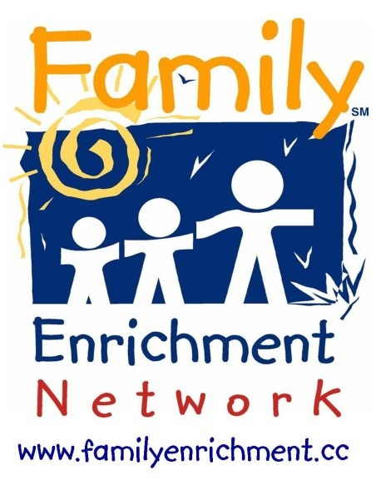










Broome County Kinship

24 Cherry St.
Johnson City NY 13790

(607) 723-8313 x831

AND

Tioga County
Kinship

(607) 723-8313 x840

The Kinship Care Program is free and available to kinship families of any income level in Broome and Tioga counties.

For information, advocacy, resources and referrals, call toll free and ask for the Kinship Care Program










Family Enrichment
Network

Love grows in
every type of family!
(607) 723-8313 x 831

1-800-281-8741






When grandparents,
other family members, friends or neighbors are raising someone else’s child, it is known as Kinship Care.

The Kinship Care Program services are free to Kinship families of any income level.

The Kinship Program provides application assistance to caregivers for these benefits:

Non-Parent Caregiver grant, SNAP, Medicaid, Childcare Subsidies and school enrollments.

Advocacy to guide kinship caregivers in obtaining needed services.

Weekly Support Groups for friendly interaction and guidance with the changes that often occur when new children are added to a household.

Peer Mentors who really understand what a kinship family is going through because of their own experiences as kinship caregivers.

Help Line to answer questions about Kinship Care and to provide up to date information on the rules & regulations governing Kinship Care.

Legal Advocacy to provide assistance in understanding court papers and referrals
to lawyers who understand kinship caregiver’s rights.

Community connections and referrals to resources available in Broome and Tioga Counties.

Parenting Support as blended families can be challenging and kinship children often arrive with worries and concerns they need addressed.

.



