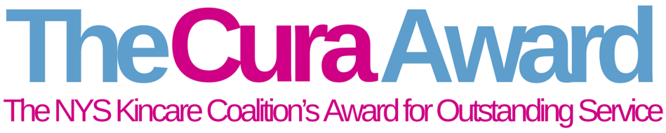

The NYS KinCare Coalition established The Cura Awards to annually recognize the outstanding achievements and contributions of those involved with kinship caregiving.
A volunteer committee will review nominations and select honorees in the following three categories:
- Outstanding Professional – An individual working in the field of kinship care or related field or that has had a significant positive impact on kinship care in New York State as a result of their work.
- Outstanding Organization – A nonprofit organization in New York State providing kinship care or that has had a significant positive impact on kinship care.
- Outstanding Kinship Caregiver – Any kinship caregiver living in New York State that has demonstrated outstanding selflessness, leadership or has overcome tremendous barriers.
- Kinship Champion: A state or national official or organization leader who has vigorously worked to help kinship families.

Finalists will be selected and notified by the end of August and the actual awards will take place at a special event each September as part of national Kinship Care Month.

APPLICATION INSTRUCTIONS

- Applications must be typed.
- Nominators should secure permission from their candidate prior to submitting their nomination. As a nominee, you consent to the Coalition photographing and using your image and likeness.
- A candidate can only be nominated for one of the three categories.
- Do not send photos, newspaper articles or support letters.
- If the information on the application is “sensitive,” please be certain that the parents/guardians are informed prior to submitting the application as information will be used in a public awards ceremony. We will withhold information upon request.

You can fill in this form by typing in the provided text boxes. Once done you will save file by: Select File -> Save As -> type in your First Name Initial and Full Last Name (ex. John Doe = JDoe).

After completing the entire application you will save the file and e-mail the completed form to Rachel Glaser at Rglaser@cfcrochester.org.

The deadline date for receipt of nominations is August 26, 2022.

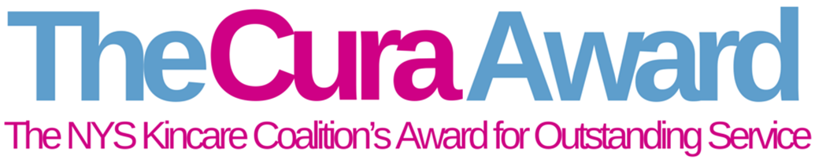

NOMINATION FORM
I nominate to be considered for this year’s Annual Cura Award for the category of (select only one):

☐ Outstanding Professional – An individual working in the field of kinship care or related field or that has had a significant positive impact on kinship care in New York State as a result of their work.

☐ Outstanding Organization – A nonprofit organization in New York State providing kinship care or that has had a significant positive impact on kinship care.

☐ Outstanding Kinship Caregiver – Any kinship caregiver living in New York State that has demonstrated outstanding selflessness, leadership or has overcome tremendous barriers

☐ Kinship Champion – A state or national official or organization leader who has vigorously worked to help kinship families.

Nominee's Name:
Street Address:
City: State: Zip Code
Phone #: Click here to enter text. Email: Click here to enter text.

Nominated by: Click here to enter text.
Organization: Click here to enter text.
Phone #: Click here to enter text.
E-mail Address:
1. Describe why your nominee should be recognized. (Limit to 200 words or less)
Click here to enter text.

2. What has been the result or impact of your nominee’s efforts? (Limit to 200 words or less)
Click here to enter text.

3. Please share any additional insight or comments that were not already address above. (Limit to 200 words or less)
Click here to enter text.
Typed nominations must be submitted by August 26, 2022 to Rae Glaser at Rglaser@cfcrochester.org

