

Caregiver Permission to Contact Form

Kinship caregivers are grandparents, other relatives, and family friends who are full time caregivers of children. The New York State Kinship Navigator is a state- wide program that provides information and assistance to kinship families and connects them with specialized services designed to support them.

By signing this form, you are giving your permission for our staff to contact you about our services and offer information about your permanency options and other services available to you.

With your permission, we will call you!
If you have questions about Kinship Navigator services, please call 877-454-6463 or email navigator@nysnavigator.org. Please go to the other side of this page, where you can complete the permission to contact form.

PERMISSION FOR THE KINSHIP NAVIGATOR TO CONTACT YOU
Caregivers: Please sign and provide your contact information below, and then return to your staff person Permission for Kinship Navigator to call you: ▢ Yes ▢ No (If no, Stop here)
Signature: Date:

Name of Primary Caregiver:
(Please PRINT legibly)
- Mailing Address: Apt Number:
City: State: Zip:
- Preferred Phone: ( ) - Alternate phone: ( ) -

Email Address:
- What language do you prefer? ▢ English ▢ Spanish ▢ Other

Preferred time and method for contact (check all that apply):
▢ Morning (9-12) ▢ Lunch time (12-1) ▢ Afternoon (1-3) ▢ Late Afternoon (3-5)
▢ Phone ▢ Email

- Would you agree for the referring worker to contact KN to inquire if contact was made? (If No, we will respect your privacy.) ▢Yes ▢ No

Referring Agency:

If referred by Child Welfare, please indicate type of placement:
▢ Safety Plan; ▢ Kinship Foster Care; ▢ KinGAP; ▢ Legal Custody; ▢ Legal Guardianship; ▢ No Formal Designation

Brief Description of CaregiverSituation/Needs:

What resources has the caregiver already been referred to:
Non-Parent Grant ▢
Kinship Care Program/ Permanency Resource Center ▢
Legal Assistance ▢
Date fax/email sent / /
(Please fax the form even if caregiver declined to be contacted; this is important for our records).
Please complete all information, and either fax this form to 585-456-1676 or email a signed copy to navigator@nysnavigator.org

The PTC - how to fill out in in 1-2-3

Step 1: The Permission!
Form must have original (not digital) signature of caregiver
(Note – PTC is best used by professionals to refer caregivers. For self-referrals, please use https://www.nysnavigator.org/contact/)

Step 2: The ‘Who!’
Caregiver info goes here – Name, Phone, etc
When do they like to be called? Do they prefer mornings? Afternoons?
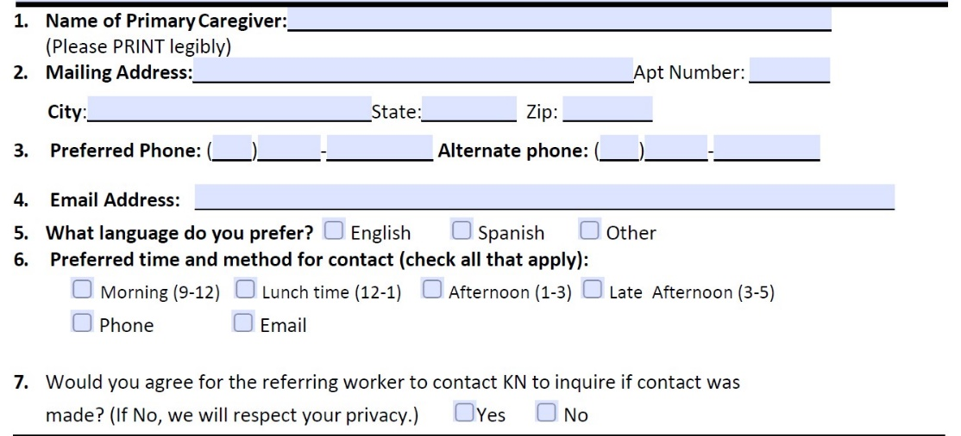
Step 3: The ‘What!’
As the Referring Agency – what can you tell us about the caregiver’s needs, and what has already been worked on? Are there critical needs to be aware of?
